INTERNATIONAL STANDARD ISO/IEC
9995-l
FCD 2005-07-07
Information technology Keyboard layouts for text and office systems -
Part 1: General principles governing keyboard layouts
Technologies de I’information Disposition des claviers conçus pour la bureautique Partie I: Principes généraux pour la disposition des claviers

Contents
Page
Scope .............................................................................................. 1
Conformance .................................................................................. 1
Normative reference ....................................................................... 2
Definitions ....................................................................................... 2
Divisions of the keyboard .......................................................... 3
Requirements ......................................... ................................... 4
Key position numbering system ............................................... 5
General principles of key labelling and symbol positioning ...... 9
Key arrangement and distances .............................................. 10
Annex
A List of standards replaced (partly or entirely) by this standard 11

B Examples of national standards 20
Foreword
IS0 (the International Organization for Standardization) and IEC (the International Electrotechnical Commission) form the specialized system for worldwide standardization. National bodies that are members of IS0 or IEC participate in the development of International Standards through technical committees established by the respective organization to deal with particular fields of technical activity. IS0 and IEC technical committees collaborate in fields of mutual interest. Other international organizations, governmental and non-governmental, in liaison with IS0 and IEC, also take part in the work.
In the field of information technology, IS0 and IEC have established a joint technical committee, lSO/IEC JTC 1. Draft International Standards adopted by the joint technical committee are circulated to national bodies for voting. Publication as an International Standard requires approval by at least 75 % of the national bodies casting a vote.
International Standard lSO/IEC 9995-l was prepared by Joint Technical Committee lSO/IEC JTC 1, Information technology, Subcommittee SC 18, Document processing and related communication.
This first edition supersedes all or part of
IS0 1090:1981
IS0 1091: 1977
IS0 1092:1974
IS0 1093:1981
IS0 2126:1975
IS0 2530: 1975
IS0 3243:1975
IS0 3244: 1984
IS0 4169:1979
IS0 8884: 1989.
For complete details, see annex A of this part of lSO/IEC 9995, provided for information only.
lSO/IEC 9995 consists of the following parts, under the general title Information technology Keyboard layouts for text and office systems:
- Part 1: General principles governing keyboard layouts
- Part 2: Alphanumeric section
- Part 3: Complementary layouts of the alphanumeric zone of the alphanumeric section
- Part 4: Numeric section
- Part 5: Editing section
- Part 6: Function section
- Part 7: Symbols used to represent functions
Part 8: Allocation of letters to the keys of a numeric keypad Annex A of this part of lSO/IEC 9995 is for information only.

Introduction
In the years prior to the existence of lSO/IEC 9995 the keyboard layout of information technology equipment (ITE) such as personal computers, workstations, and computer terminals was determined by standards which were originally intended for typewriters, adding machines and the like. This led to the fact that designers of office machine keyboards had to choose from the sometimes inconsistent standards, which in turn led to the existence of widely dissimilar keyboard layouts.
lSO/IEC 9995 defines a framework for the layout of keyboards for ITE. The functions to be performed by keyboards are grouped into four categories that correspond to the four physical sections of the keyboard.
Application of lSO/IEC 9995 in the design of keyboards will provide the user with a unified, predictable interface between the user and office machines by dividing the keyboard into functional areas and sections and allocating functions to keys. One of the major tasks is to accommodate the larger and/or multiple sets of characters required by the various applications for which keyboards are used today. This was achieved by permitting the allocation of more than one graphic character or control function to each of the keys of a keyboard, predominantly in the alphanumeric section.

Information technology Keyboard layouts for text and office systems
Part 1:
General principles governing keyboard layouts

1 Scope
lSO/IEC 9995 specifies various characteristics of keyboards used by ITE e.g.
a) personal computers, workstations, computer terminals, VDTs (visual display terminals), typewriters, etc, having an alphanumeric keyboard;
b) calculators, telephones and automated teller machines having a numeric keypad.
The keyboard defined in lSO/IEC 9995 is the conventional linear keyboard, which is physically divided into sections and the sections into zones within which the keys are laid out.
In this part of lSO/IEC 9995, the sections of the keyboard are identified and the general shape and relative placement of the sections are specified. Spacing of keys and physical characteristics are covered in this part of lSO/IEC 9995 as are the principles governing the placement of characters and symbols on keys.
This part of ISO/IEC 9995 specifies a key numbering system which applies to all types of numeric, alphanumeric and composite keyboards of ITE.
This part of lSO/IEC 9995 specifies the principles governing the placement of characters and symbols on keys used on all types of numeric, alphanumeric and composite keyboards of ITE. Although the keyboard defined by lSO/IEC 9995 may be used for different languages, the specifications are written as applying to Latin languages with a character path from left to right and a line progression from top to bottom.
The primary layout within the alphanumeric zone is established in most countries by a national standard or by national usage. Allocation guidelines are provided in lSO/IEC 9995-2. Complementary layouts are specified in lSO/l EC 9995-3.
This part of lSO/IEC 9995 defines characteristics related to interface 1 in figure 1.
lSO/IEC 9995 specifies the allocation of functions (graphic characters and/or control functions) to keys. The graphic characters and the control functions have been given common names intended to be familiar to the users of a keyboard. In general, keyboards are not expected to generate coded control functions, but the operation of a control function key may cause a number of coded control functions to appear in data interchange to achieve the desired effect.
The effects of those keys that affect keyboard states are specified in other parts of lSO/IEC 9995.

2 Conformance
2.1 Conformance with part 1
Equipment is in conformance with lSO/IEC 9995-l if it meets the requirements of clauses 5 to 9. Depending on the intended purpose of the equipment not all of the described sections and zones need to be implemented.
2.2 General conformance requirement
A keyboard which claims conformance with lSO/IEC 9995 shall at minimum conform to this part of lSO/IEC 9995 and to all other parts which are relevant to that particular model of keyboard.
Conformance to lSO/IEC 9995-7 does not require conformance to any other part of lSO/IEC 9995.
Conformance to lSO/IEC 9995-8 does not require conformance to any other part of lSO/IEC 9995.
2.3 . Claims of conformance
Any claim of conformance with lSO/IEC 9995 shall list the parts of lSO/IEC 9995 to which conformance is claimed.

3 Normative reference
The following standard contains provisions which, through reference in this text, constitute provisions of this part of lSO/IEC 9995. At the time of publication, the edition indicated was valid. All standards are subject to revision, and parties to agreements based on this part of lSO/IEC 9995 are encouraged to investigate the possibility of applying the most recent edition of the standard indicated below. Members of IEC and IS0 maintain registers of currently valid International Standards.
IS0 9241-4:1998, Ergonomic requirements for office work with visual display terminals (VDTs) Part 4: Keyboard requirements.
ISO 9241-4:1998/Cor 1:2000, Ergonomic requirements for office work with visual display terminals (VDTs) Part 4: Keyboard requirements – Corrigendum 1.

4 Definitions
For the purposes of this part of lSO/IEC 9995, the following definitions apply.
4.1 active position: The character position which is to image the graphic symbol representing the next graphic character or relative to which the next control function is to be executed.
NOTE 1 In general, the active position is indicated in a display by a cursor.
4.2 associated system: The system to which the keyboard is attached, probably consisting of a processor and software to handle the keyboard and to run application programs.
4.3 capitals lock state: A state that, if activated, will result in the generation of the capital form of all graphic characters on the keyboard for which such a form exists. National standards or usage may determine which graphic characters are affected by this state.

4.4 control function: An action that affects the recording, processing, transmission, or interpretation of data.
4.5 function key: A key whose primary purpose is the input of a control function. Function keys are found in all sections of the keyboard.
4.6 graphic character: A character, other than a control function, that has a visual representation normally handwritten, printed or displayed.
4.7 graphic key: A key whose primary purpose is the input of a graphic character or of an element of a graphic character. Certain of these keys may also have a secondary purpose for input of a control function.
4.8 graphic symbol: A visual representation of a graphic character, a control function, or a combination of one or more graphic characters and/or control functions.
4.9 group: A logical state of a keyboard providing access to a collection of graphic characters or elements of graphic characters. Usually these graphic characters or elements of graphic characters logically belong together and may be arranged on several levels within a group. The input of certain graphic characters, such as accented letters, may require access to more than one group.
4.10 group select: A function that, if activated, will change the keyboard state to produce characters from a different group.
4.11 key effect: The effect that results when a key is actuated, depending on the level in force, and possibly by the concurrent operation of a qualifier key or keys. The key effect may be the generation of a graphic character or of a control function.
4.12 level: A logical state of a keyboard providing access to a collection of graphic characters or elements of graphic characters. Usually these graphic characters or elements of graphic characters logically belong together, such as the capital forms of letters In certain cases the level selected may also affect function keys.
4.13 level select: A function that, if activated, will change the keyboard state to produce characters from a different level.
4.14 level lock state: A state that, if activated, will result in the generation of the characters assigned to a specific level.
4.15 lock state: The state set by actuating a lock key, singly or in combination with a qualifier key.
4.16 primary group layout: The allocation of the graphic characters of group 1 to the keys of a particular keyboard, defined by a national standard or established by common usage in a particular country or group of countries.
4.17 qualifier key: A key the operation of which has no immediate effect, but which, for as long as it is actuated, modifies the effect of other keys. A qualifier key may be, for example, a level select key or a control key.
4.18 secondary group layout: The allocation of the graphic characters of group 2 to the keys of a particular keyboard.
4.19 section: A block of keys, mostly with some functional relationship.
4.20 zone: A part of a keyboard section defined in ISO/IEC 9995.

5 Divisions of the keyboard
For the purpose of this standard the keyboard is considered as an intermediate element between a user and an information processing system. The keyboard is specifically intended as a means for input of information by a human being, see figure 1.
Simply stated, the keyboard functions as follows:
the user actuates one or more keys (event at interface 1)
corresponding signals are sent to the information processing system (event at interface 2)
For the purpose of this International Standard the keyboard is considered to be divided logically into groups and levels and physically into sections and zones.
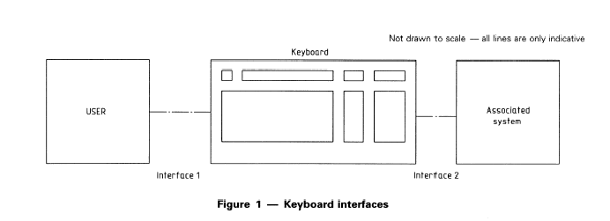

5.1 Logical division of keyboard into groups and levels
The graphic characters or control functions which may be accessed by one key are logically arranged in groups and levels. The traditional shift function has been extended to permit access to these different groups and levels. The selection among the available groups and levels is controlled by the user by means of one or more select mechanisms (see table I).
Two kinds of select mechanisms are recognized here:
- Group select: enables selection among groups
- Level select: enables selection among levels
The two functions can apply simultaneously. In a hierarchical sense the group is higher than the level; within a group several levels may be defined.

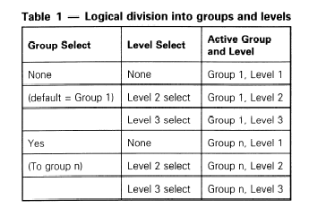

Groups are likely to contain complete or distinctive sets of functions. A keyboard could have any number of groups, practicality of use being a limiting factor.
Within each group, functions (graphic characters and/or control functions) are arranged on up to three levels.
Groups beyond group 1 are accessed via a group select function. Level 1, formerly called the unshifted level, is accessible without a level select function. The level 2 select function provides access to level 2, formerly called the shifted level. Level 3, which did not exist in previous standards, is accessed through an additional level select function provided for that purpose.
The concept of selecting groups and levels can be applied to sections of the keyboard other than the alphanumeric section.
5.2 Physical division of keyboard into sections and zones
This subclause introduces the concept of sections and zones. The details of sections and zones are defined in subsequent parts of lSO/IEC 9995.
The various functions that can be performed by a keyboard are grouped into four categories, arranged in four keyboard sections as follows:
alphanumeric section, zones ZAO ZA4;
editing section, zones ZEO ZE2;
function section, zones ZFO ZF4;
numeric section, zones ZNO ZN6.
Each of the sections may be regarded as consisting of a central core (zone 0) surrounded by other zones which may be used for supporting function keys or other related keys.
In figure2 the general arrangement of sections and zones is shown.
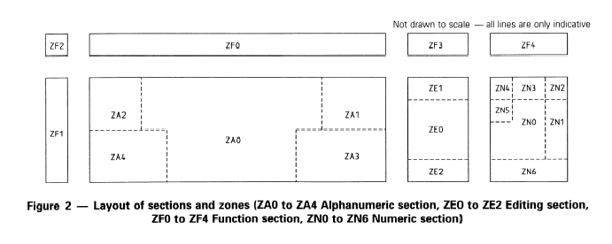

6 Requirements
6.1 Placement of sections
ITE keyboards including office machine keyboards may consist of one or more sections all of which are of indeterminate size. Each of the sections can be used in a stand-alone configuration. If an alphanumeric section is present on the keyboard the physical arrangement of the sections shall be as follows:
- editing section, if present, to the right of the alphanumeric section, or to the left (specifically for left-handed people)
- numeric section, if present, to the right of the alphanumeric section, if present, or to the left of the alphanumeric section (specifically for left-handed people).
- function section if present, above or on one of the extreme sides of the other sections
The exact positions are not standardized, but it is preferred that row A of all sections should be aligned (see clause 7). However If both the editing section and the numeric sections are present, the editing section shall be placed between the alphanumeric section and the numeric section. The ZF1 sub-zone, if present, shall be placed beyond the exterior side opposite to the one chosen for the editing or the numeric section.

The general arrangement is shown in figure2.
6.2 Methods of indicating allocations to keys
A graphic symbol that represents a graphic character or a control function that is allocated to a key in a particular position on a keyboard, in accordance with lSO/IEC 9995, shall be shown on that key in such a way that the allocation can be observed by the user of the keyboard. The allocation shall be shown by one or more of the following methods, method a) being the usual and preferred one:
a) by visible indications on the keytops in accordance with clause 8 of this part of lSO/IEC 9995;
b) by visible indications elsewhere on the keyboard;
c) by information contained within a product description that accompanies the keyboard;
d) by information made available to the user by means of associated equipment that is normally used with the keyboard.
If any allocations are shown by either method c) or d), the corresponding product description or other information shall be provided with the keyboard.
Each allocation of a control function that is shown as specified above shall be identified either by the symbol specified in lSO/lEC 9995-7, or by the name specified there, or by an equivalent name in another language.

7 Key position numbering system
7.1 Principle of the grids
The numbering system specified in lSO/IEC 9995 is related to a set of layout charts, each based on a grid (intersection of rows and columns). The purpose of each grid is to show the relative position of the keys in the layout of one keyboard section. Grids are specified below for four separate sections: the alphanumeric section, the editing section, the numeric section, and the function section.
Depending on the user requirements, and for compatibility with existing keyboards, the grid of the alphanumeric section can be angled (see figure3) or square (see figure4). lSO/IEC 9995 expresses no preference for either the square or angled alphanumeric section, nor does it specify the angle.
All the sections are envisaged as being divided into a number of zones. In the case of the function section the zones are not necessarily contiguous, and the numbering system reflects this.
In the case of overlapping sections, the columns affected shall be identified by both numbers of the overlapping sections.
The layout of the grids of the different parts of a keyboard are shown in the figures 3 to 7. The reference row and the relevant reference columns have been shaded to permit easy identification.
7.2 Designation of key positions
Eat h key position in each of the grids is identified by the intersection of a row and a column.
The rows and the columns are identified as follows:
Each row is identified by a capital letter of the Latin alphabet.
Row A is designated as the reference row of the alphanumeric section, the editing section, the numeric section, and zone ZFI of the function section. Rows above the reference row are identified by the sequence B, C, D, E and so on, as far as necessary. Rows below the reference row, if provided, are identified by the sequence Z, Y, X and so on, as far as necessary.
Row K is designated as the reference row of the zones ZF2, ZFO, ZF3 and ZF4 of the function section. Rows above the reference row K are identified by the sequence L, M, N and so on, as far as necessary.
Each column is identified by a two-digit number.
Column 01 is designated as the reference column of the alphanumeric section and of zone ZFO of the function section. Columns to the right of the reference column are identified by the sequence 02, 03, 04 and so on, as far as necessary. Columns to the left of the reference column are identified by the sequence 00, 99, 98 and so on, as far as necessary.
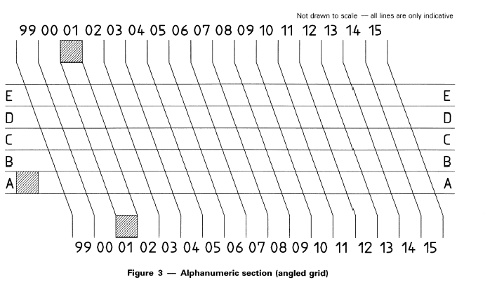

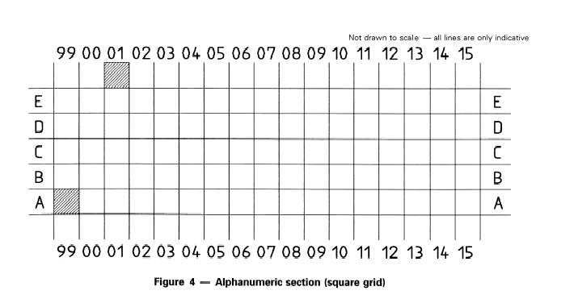

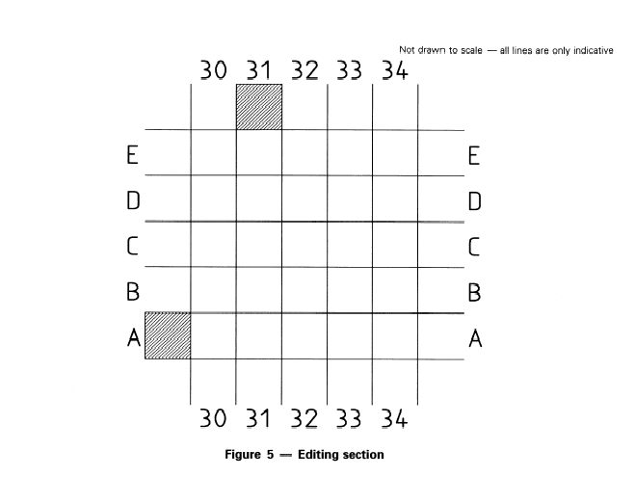

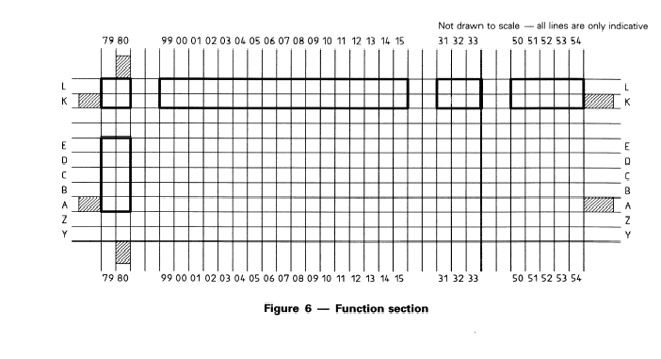

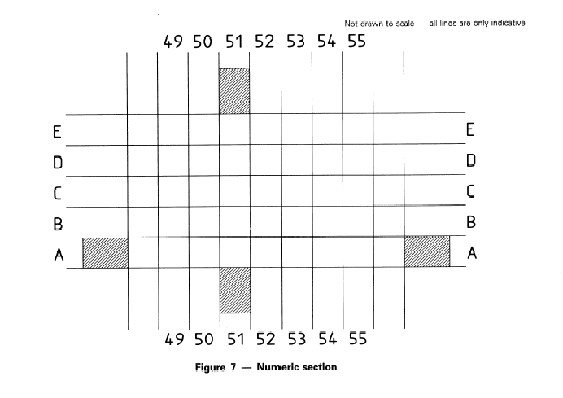

Column 31 is designated as the reference column of the editing section and of zone ZF3 of the function section. Columns to the right of the reference column are identified by the sequence 32, 33, 34 and so on, as far as necessary. Columns to the left of the reference column are identified by the sequence 30, 29, 28 and so on, as far as necessary.
Column 51 is designated as the reference column of the numeric section and of zone ZF4 of the function section. Columns to the right of the reference column are identified by the sequence 52, 53, 54 and so on, as far as necessary. Columns to the left of the reference column are identified by the sequence 50, 49, 48 and so on, as far as necessary.
Column 80 is designated as the reference column of zone ZFl and zone ZF2 of the function section. Columns to the left of the reference column are identified by the sequence 79, 78, 77 and so on, as far as necessary.
7.3 Reference positions for the rows and columns
The reference rows and the relevant reference columns are defined as follows:
Row A is the row containing the space bar in the alphanumeric section.
Row K is the row containing the key in the function section to which the escape function is allocated.
Column 01 is the column containing the key with the digit one in the alphanumeric section.
Column 31 is the column containing the key with the control function cursor left in the editing section.
Column 51 is the column containing the key with the digit one in the numeric section.
Column 80 is the rightmost column of zones ZFl and ZF2 of the function section.
7.4 Key location numbering requirements
If a description of a keyboard uses a numbering system and/or layout charts other than those described in 7.1 and 7.2, information shall be provided about how to map that numbering system on to the system specified in this part of lSO/IEC 9995. This information shall be contained in a product description that accompanies the keyboard.

8 General principles of key labelling and symbol positioning
This part of ISO/IEC 9995 does not require the labelling of all allocations in all levels of all groups on a key, it does not deal with the color, the shape, the font or even the size of a particular character or symbol on a key. It defines general principles for the placement of these symbols on any key, plus other considerations for uniformity or unambiguity of labelling.
At least one symbol representing a graphic character or a control function shall be shown on every key to which a graphic character or a control function is a located, the space bar excepted.
Symbols which represent functions are defined in lSO/IEC 9995-7.
8.1 Group positions
All symbols that are shown on a key and that represent graphic characters within the same group, shall be placed within the same column on the key. More than one such column of symbols may be placed on the key side by side.
If symbols from more than one group are shown, symbols representing group I allocations shall be placed on the far left side of the key and symbols representing group 2 allocations shall be placed on the far right side of the key. Optionally, symbols representing another group’s allocations may be placed in the middle column of the key.
8.2 Level positions within one group
The placement of symbols representing graphic characters or control functions allocated to different levels in one group is done using different rows in the column assigned to that group. lSO/IEC 9995 allows for up to three levels within any one group.
Two scenarios are possible for their placement.
8.2.1 Labelling of all three levels on the key-top
The symbols representing the level 1 allocation shall be placed in the middle third of the group’s column of the keytop. The symbols representing the level 2 allocation shall be placed in the upper third of the group’s column of the keytop, see figure 8. The symbols representing the level 3 allocation shall then be placed in the lower third of the group’s column of the keytop. In the case when a single symbol represents the first two levels at the same time (like the graphic symbol M representing at the same time capital letter M and small letter m), the symbol may be enlarged and occupy the upper two thirds of the group’s column of the keytop.
8.2.2 Labelling of two levels on the key-top, labelling of level 3 on the keyface
In this case the symbols representing the level 3 allocation shall be placed on the front face of the key, in the same column as the symbols representing the allocation of level 1 and 2. The symbols representing the level 1 allocation shall then be placed in the lower half of the group’s column of the keytop, see figure9. The symbols representing the level 2 allocation shall then be placed in the upper half of the group’s column of the keytop. In the case when a single symbol represents both the level 1 and level 2 allocations at the same time (like the graphic symbol M representing at the same time capital letter M and small letter m), this graphic symbol may be enlarged and occupy the upper half of the group’s column of the keytop.
8.3 Capital/small letter pairs
Where there is a pair of capital/small letters allocated to levels 1 and 2 of any group on the same key, the graphic symbol for the small letter need not be shown on the key.
8.4 Minimum required size of keytop symbols
The minimum required size of keytop symbols is specified in IS0 9241-4.

9 Key arrangement and distances

9.1 Key layout
The key layout for each section is specified in the respective part of lSO/IEC 9995.
9. 2 Other requirements
For other requirements (such as keytop dimensions and surfaces, slope of the keyboard, key displacement and key force, distance between keys), see

IS0 9241-4.
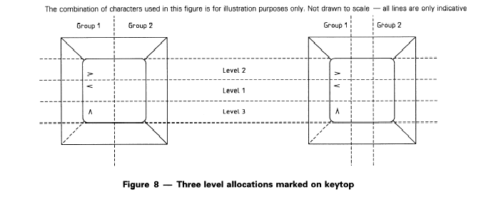

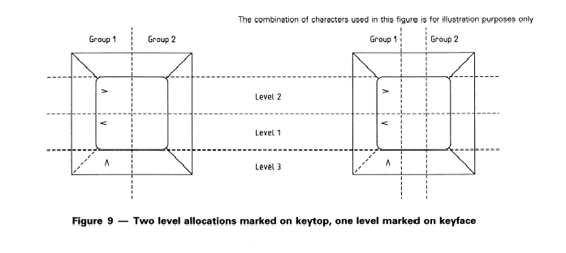

Annex A (informative)
List of standards replaced (partly or entirely) by this standard

Some of the specifications in the IS0 Standards listed in the Foreword have not been included in the relevant parts of this International Standard. Those specifications that were not taken over, but are of relevance, are mentioned below.
IS0 1090: The symbols not included in part 7 of this International Standard are specified in IS0 7000.
IS0 1091: Key distances are defined in IS0 9241-4.
IS0 1092: Slope, key distances, key stroke, and other specifications are specified in IS0 9241-4.
IS0 1093: The symbols not included in part 7 of this International Standard are specified in IS0 7000.
IS0 2126: This standard is replaced in its entirety.
IS0 2530: This standard is replaced in its entirety. IS0 3243: This standard is replaced in its entirety. IS0 3244: This standard is replaced in its entirety. IS0 4169: This standard is replaced in its entirety. IS0 8884: This standard is replaced in its entirety.
NOTE 2 It was originally intended to also replace the IS0 Standards 3791 and 3792 which deal with adding machines and calculators. The principles outlined in the different parts of this International Standard, especially those in part 4, are valid for this kind of machine also. They are to be applied when designing adding machines or calculators. Equipment of this kind is too specific and the existing IS0 Standards are therefore not cancelled and not replaced by this International Standard.
Annex B (informative)
Examples of national standards

- Canada CAN/CSA Z243.200-92 – Canadian keyboard standard for the English and French languages (Norme canadienne de clavier pour le français et l’anglais)

- Germany DIN 2137 series, Büro – und Datentechnik, Tastaturen für Schreibmaschinen

- Sweden SS 66 22 41 Informationsteknisk utrustning - Alfanumeriskt tangentbord för svenskt bruk

- UK BS 4822 : BS 4822:1994 Specification for keyboard allocation of graphic characters for data processing

- USA ANSI INCITS 154 : Office Machines and Supplies - Alphanumeric Machines - Keyboard Arrangement (formerly ANSI X3.154-1988 (R1999))

